Pointer
_______________________________________________________________________________
Pointer is a derived data type and which is used for allocates dynamic memory or use for dynamic memory allocation purpose
Q. what is derived data type?
______________________________________________________________________________
Those data type acquire the properties from another data type for complete its meaning called as derived data type.

Q. what is meaning of dynamic memory allocation?
___________________________________________________________________________________
To decide how much memory required at program run time called as dynamic memory allocation.

Example: dynamic memory allocation helps us to overcome the limitation of static memory allocation
static memory allocation means we fix the memory size in program compile time example of static memory allocation is array
Suppose consider we have array of size 5 then we cannot store 10 values in it and suppose consider we have array of size 500 and if we store 2 values in it then 498 block of memory get waste
So we need a solution which can provide 2 block at run time and if we required 500 block or 5000 block or unlimited block of memory at run time called as dynamic memory allocation.

How to use pointer in c language
_________________________________________________________________________________
If we want to use pointer in c language we have to use following syntax
Syntax: datatype *variablename;

Example: int *ptr;
If we think here we have ptr is a pointer variable and ptr can allocate dynamic memory

How pointer allocate dynamic memory
_______________________________________________________________________________
Pointer can allocate dynamic memory by storing address of another memory address.

Q. what is memory address?
______________________________________________________________________________
Memory address is unique integer number provided by ram to the every memory block.
Means when we declare any variable then we have block in memory and ram provide specific number to that block called as memory address

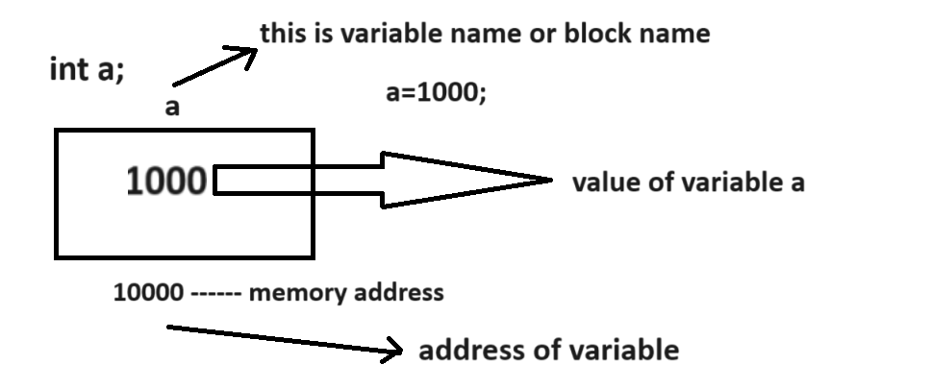

Can we see the address of variable?
________________________________________________________________________________
If we want to see the address of variable we have to use & operator in c language.
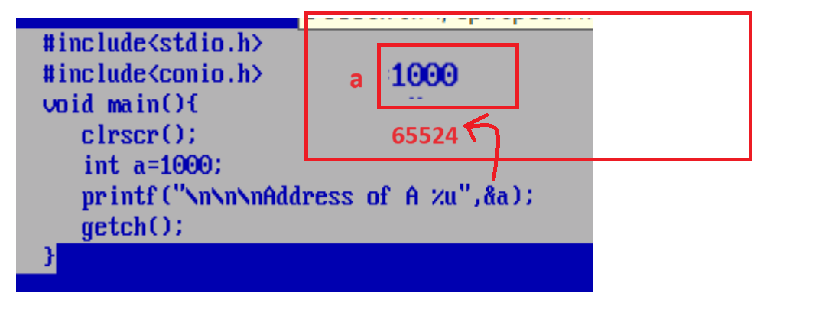

Output: Address of A 65524

If we want to allocate dynamic memory by using pointer we have to store address of another variable in pointer variable

How to store address of another variable in pointer variable
____________________________________________________________________________________
Syntax:
pointervariable =&normalvariable;

Important points related with pointer
1. Pointer always uses the address of another variable and pointer has own different address
2. If we store address of particular variable in pointer then we can use the values of that variable using pointer or value on that address use by pointer.
If we want to access the value using pointer whose address stored in it then we required to use * with pointer variable.
3.if we increase or decrease pointer by address then pointer get increase by block and block size is dependent on data type and when we pointer shift new block then pointer release the address of previous memory and points to new memory
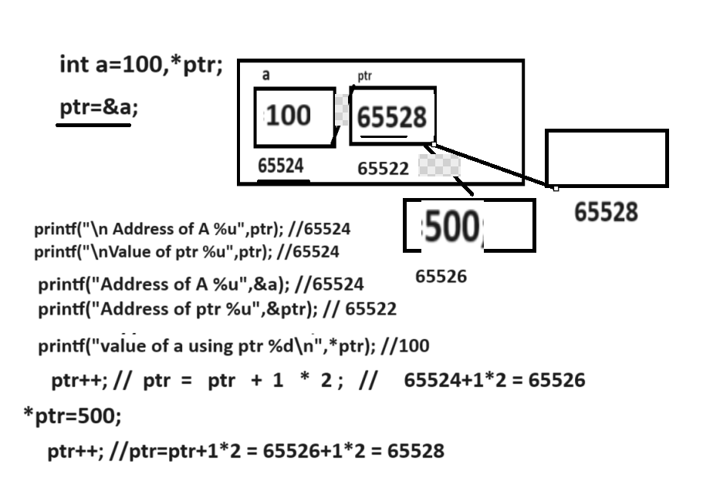

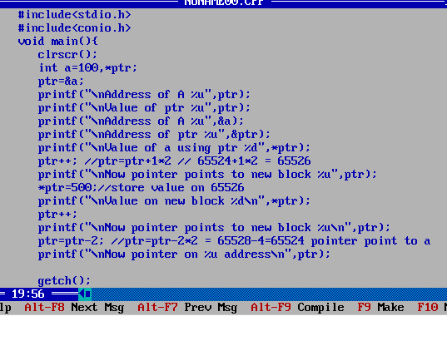

How to allocate run time memory by using pointer
_____________________________________________________________________________
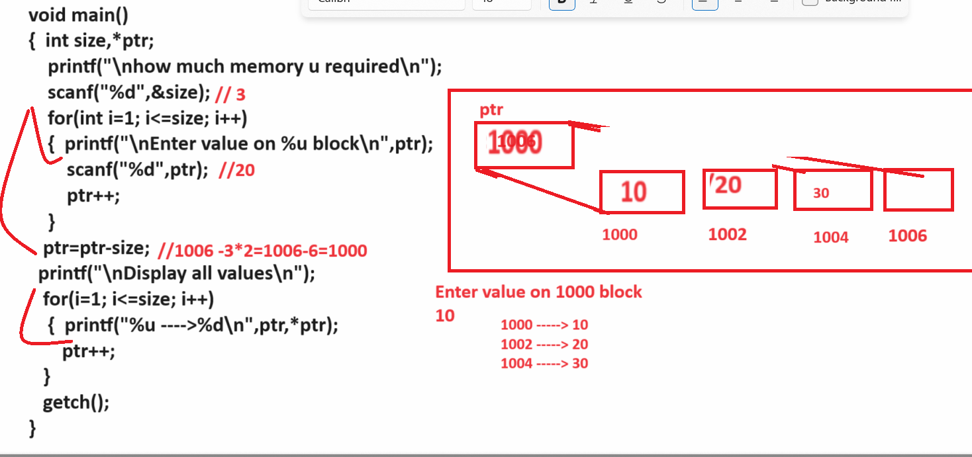

Source code
#include<stdio.h>
#include<conio.h>
void main(){
clrscr();
int size,*ptr,i;
printf("\nHow much memory u reuqired\n");
scanf("%d",&size);
for(i=1; i<=size;i++)
{ printf("\nEnter value on %u block\n",ptr);
scanf("%d",ptr);
ptr++;
}
ptr=ptr-size;
printf("\ndispay all values\n");
for(i=1;i<=size;i++)
{
printf("%u ---->%d\n",ptr,*ptr);
ptr++;
}
getch();
}
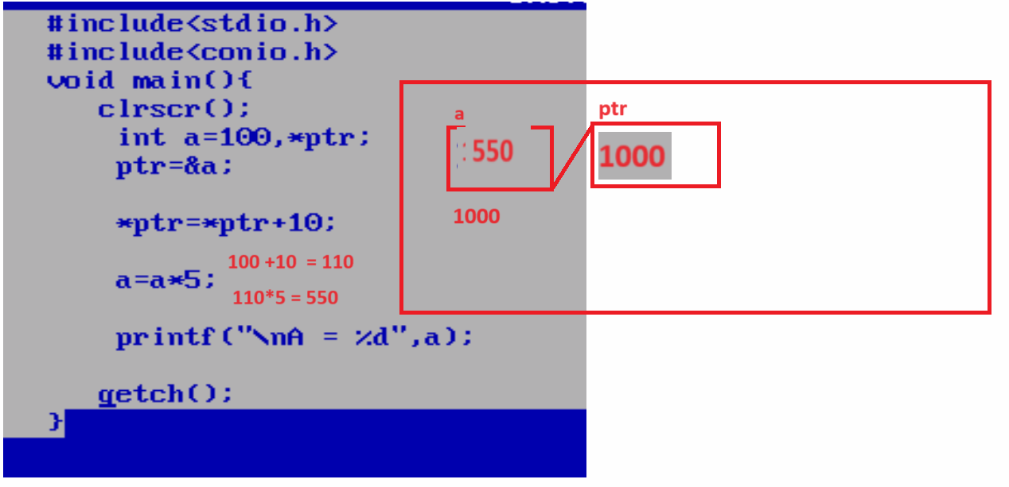

Application of pointers and types of pointer
____________________________________________________________________________
1. Work with array
2. Work with String
3. Work with function
4. Work with structure etc

Types of pointer
1. void pointer or generic pointer
2. dangling of pointer
3. null pointer
4. far pointer
5. huge pointer
6. near pointer

How to access array by using a pointer?
___________________________________________________________________
If we want to access array by using a pointer we have to store base address of array in pointer

Q. what is base address?
_____________________________________________________________________
Base address means 0th location address called as base address.

How to get the base address of array?
_________________________________________________________________
if we want to get base address of array we have two ways
1. Use array without subscript or [] bracket
2. Use array &arrayname[0];

Example:
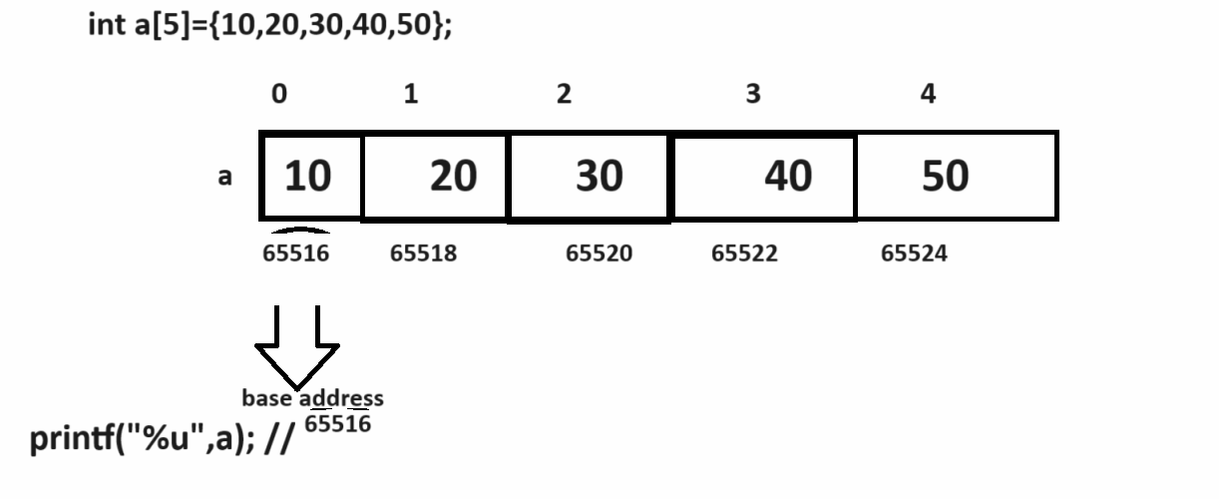
Note: for verify above diagram we can use following code.
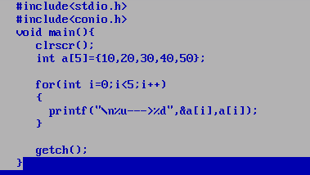
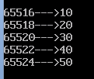

Access array using pointer
____________________________________________________________________
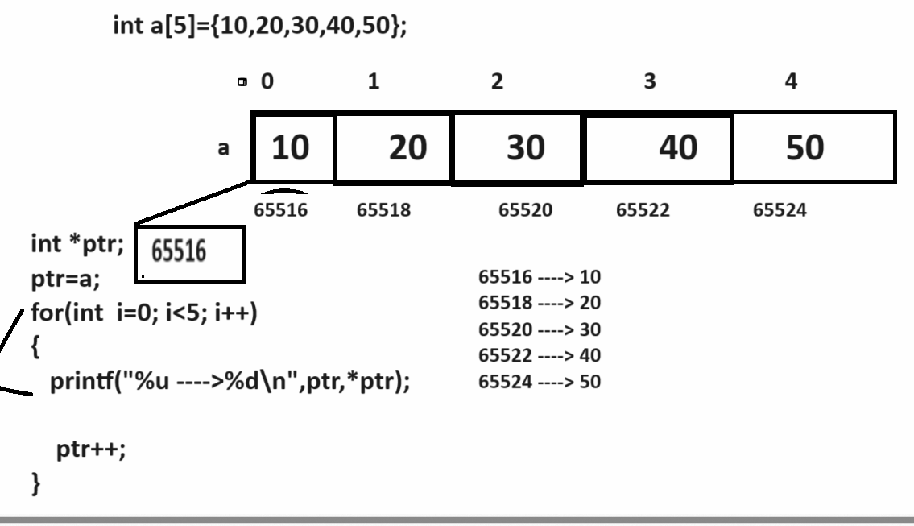

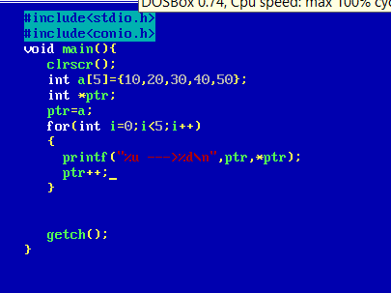

Q. what is meaning of array[i]?
_______________________________________________________________
base address + index *size;

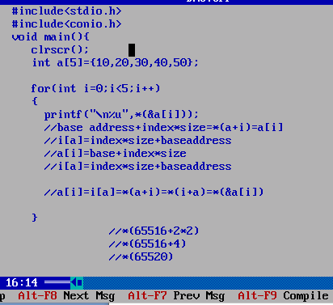

Types of Pointer
_________________________________________________________________________
1. void pointer: void pointer is generic pointer means we can store any type of address in void pointer.
but we need to convert it in appropriate type as per our requirement
Syntax:
void *variablename;

Example: void *ptr;
if we think here ptr is variable of void pointer means we can store any type of address in ptr variable.

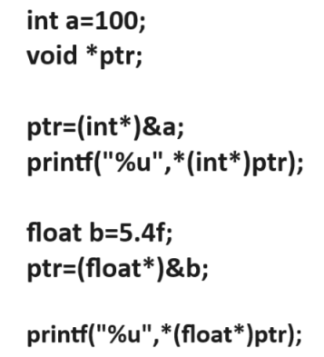

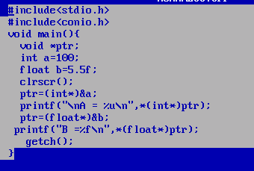

Dynamic memory allocation functions
__________________________________________________________________________________
Dynamic memory allocation function helps us to allocate memory at run time by using pointer

1. malloc: malloc function is used for allocate memory at program runtime and create dynamic array at program run time.

Syntax: pointervariable=(void*)malloc(size);

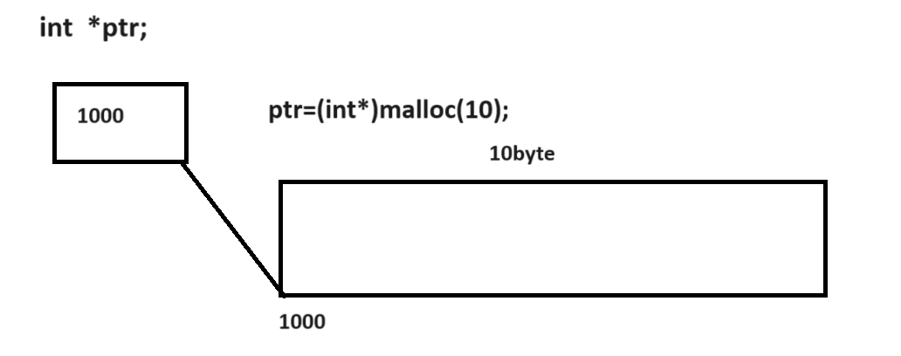
Example: we want to create program to create dynamic array by using malloc
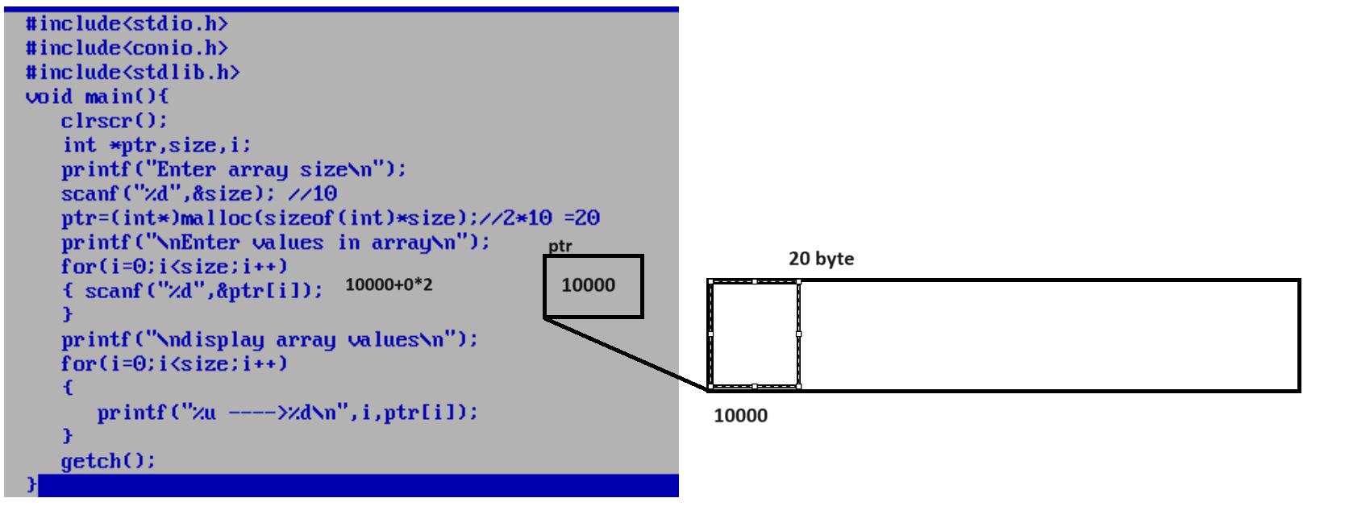

Example: WAP to create array by using malloc and find the value from array
#include<stdio.h>
#include<conio.h>
#include<stdlib.h>
void main(){
clrscr();
int *ptr,size,i,max;
printf("Enter array size\n");
scanf("%d",&size); //10
ptr=(int*)malloc(sizeof(int)*size);//2*10 =20
printf("\nEnter values in array\n");
for(i=0;i<size;i++)
{ scanf("%d",&ptr[i]);
}
max=ptr[0];
printf("\ndisplay array values\n");
for(i=0;i<size;i++)
{ printf("%u ---->%d\n",i,ptr[i]);
if(ptr[i]>max)
{ max=ptr[i];
}
}
printf("\nMax Value is %d\n",max);
getch();
}

2. realloc: realloc function is used for reallocate memory allocated by malloc means suppose consider if we allocate memory using malloc and if we want to extend memory size at program run time then we can use realloc function.
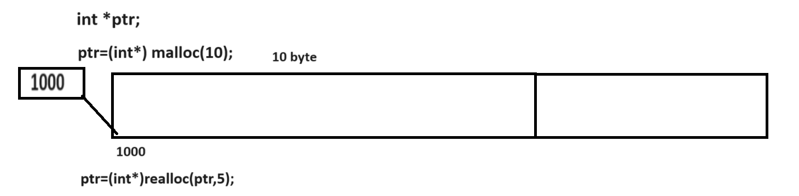

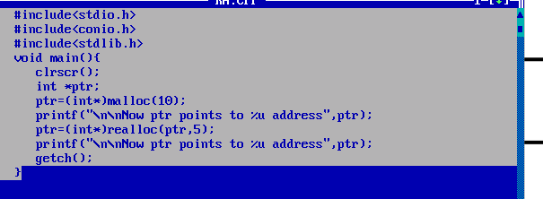

Example using realloc function
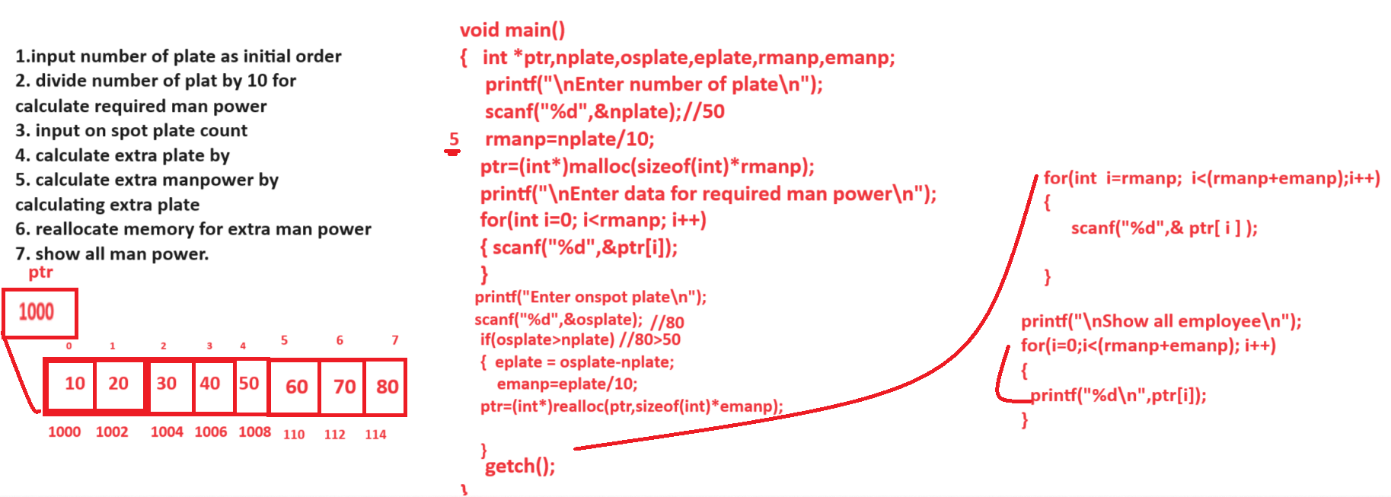

Source code.
#include<stdio.h>
#include<conio.h>
#include<stdlib.h>
void main(){
int *ptr,nplate,osplate,eplate,rmanp,emanp,i;
clrscr();
printf("\nEnter number of plate\n");
scanf("%d",&nplate);
rmanp=nplate/10;
ptr=(int*)malloc(sizeof(int)*rmanp);
printf("\nenter code of employee\n");
for(i=0; i<rmanp;i++)
{ scanf("%d",&ptr[i]);
}
printf("\nEnter on spot plate\n");
scanf("%d",&osplate);
if(osplate>nplate)
{ eplate=osplate-nplate;
emanp=eplate/10;
ptr=(int*)realloc(ptr,sizeof(int)*emanp);
printf("\nenter code for new employee\n");
for(i=rmanp;i<(rmanp+emanp);i++)
{ scanf("%d",&ptr[i]);
}
printf("\nDisplay all employees\n");
for(i=0; i<(rmanp+emanp); i++)
{ printf("%d\t",ptr[i]);
}
}

getch();
}
3. calloc : calloc stands for continuous memory allocation function it is used for allocate memory at program run time like as malloc but the major difference between malloc and calloc is malloc allocate only one block and store garbage value in it and calloc allocate continuous memory block of specified size the default is zero in memory allocated by calloc.

Syntax: pointer=(void*)calloc(size,datatype);
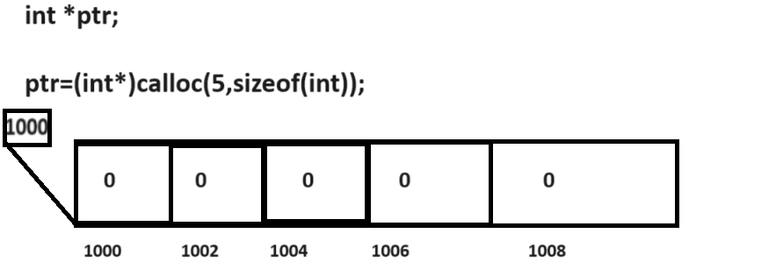
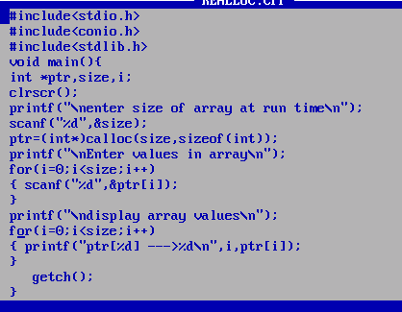

4. free : free() function is used for release the memory allocated by pointer
Syntax: void free (void*): this function can accept any type of pointer in it for release memory.
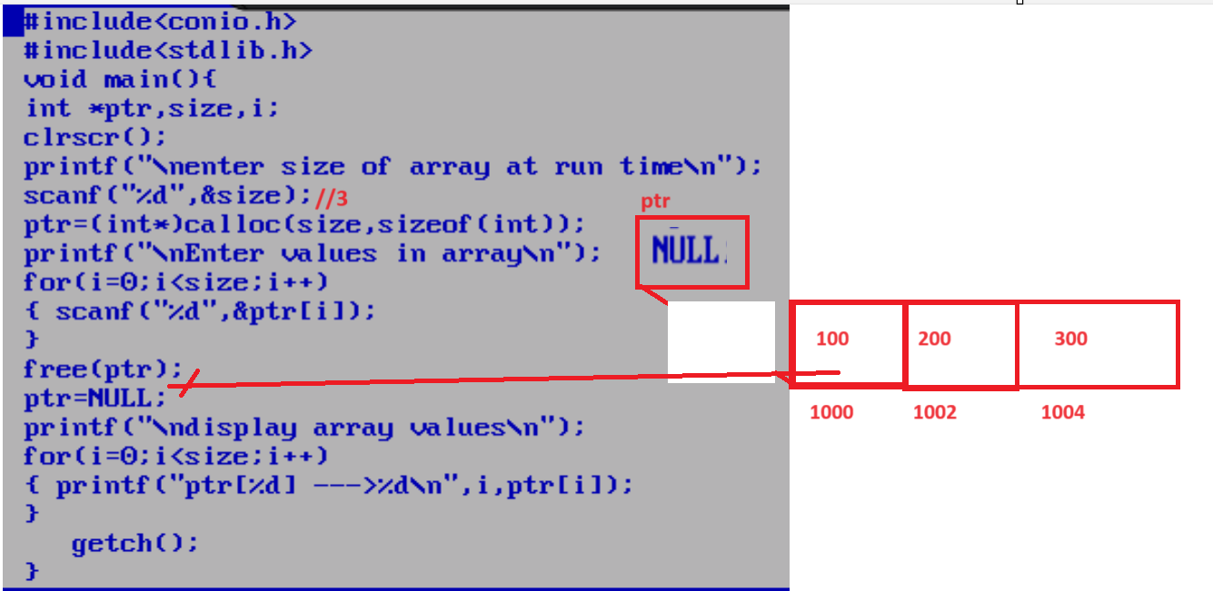

Q.what will be output of given code?
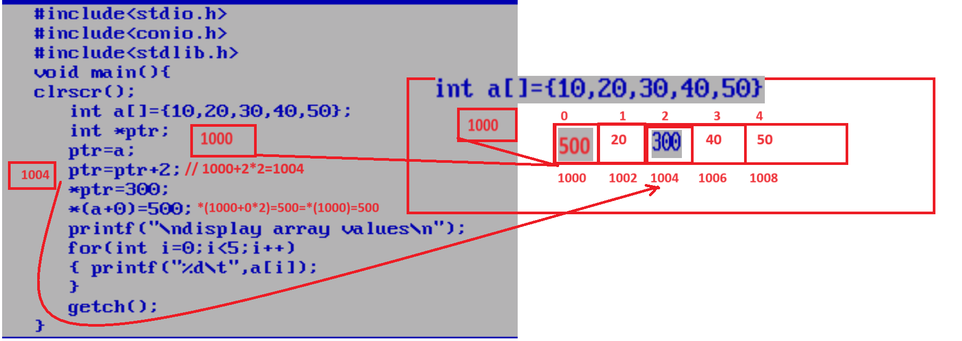

Q. what will be output of given code?
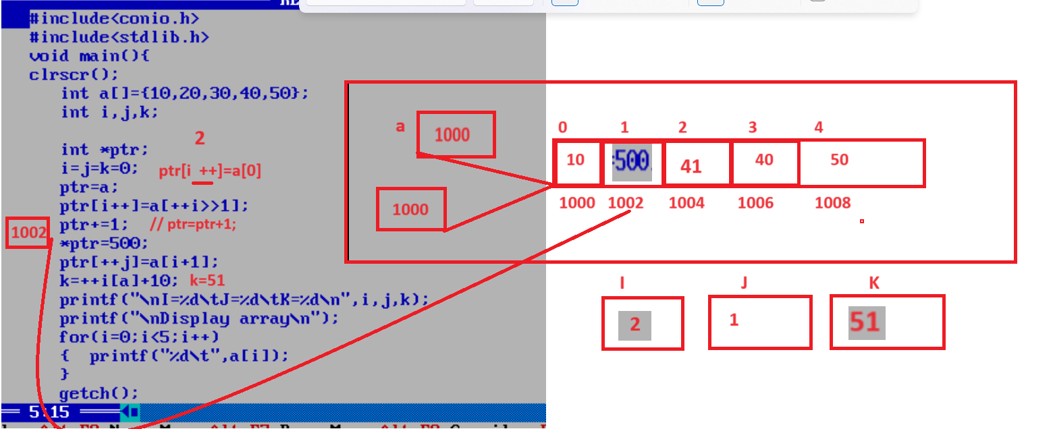

Q. what will be output of given code?
